STRING PROGRAM
1) compare two string
class Main{
public static void main(String[] args){
String first = "java programming";
String second = "java programming";
String third = "programming";
boolean result1 = first.equals(second);
System.out.println("string first and second are equal:"+result1);
boolean result2 = first.equals(third);
System.out.println("string first and third are equal:"+result2);
}
}
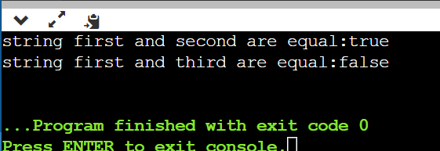
2) upper and lower case string
class Main{
public static void main(String[] args){
String s = "Hello World";
System.out.println(s.toUpperCase());
System.out.println(s.toLowerCase());
}
}
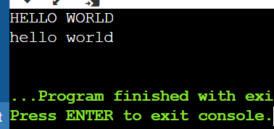
3)find e word in given spelling
class Main{
public static void main(String[] args){
String a = "Umbrella";
boolean per = false;
for(int i=0;i<a.length();i++){
if(a.charAt(i) == 'e'){
per=true;
break;
}
}
System.out.println(per);
}
}
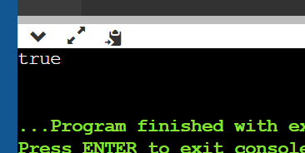
4)length of string
class Main{
public static void main(String[] args){
String a = "refrigerator";
System.out.println(a.length());
}
}
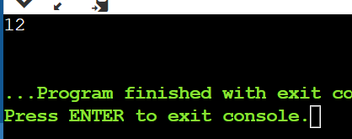
5)join two string
class Main{
public static void main(String[] args){
String first = "Java";
System.out.println("first string:"+first);
String second = "Program";
System.out.println("second string:"+second);
String joinedString = first.concat(second);
System.out.println("Joined string:"+joinedString);
}
}
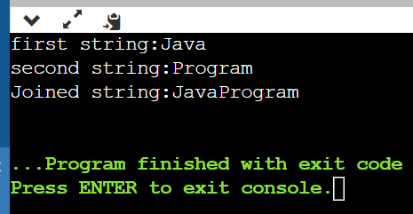
6)upper or lower case
import java.util.Scanner;
class Main{
public static void main(String[] args){
Scanner sc = new Scanner (System.in);
System.out.println("enter string:");
String s = sc.nextLine();
System.out.println("enter choose:");
int i=sc.nextInt();
switch(i){
case 0:
System.out.println("Lowercase:"+(s.toLowerCase()));
break;
case 1:
System.out.println("Uppercase:"+(s.toUpperCase()));
break;
}
}
}
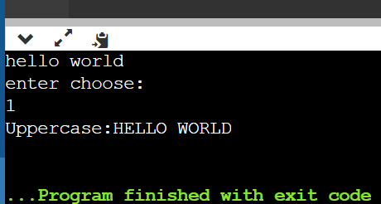
7)
import java.util.Scanner;
class Main{
public static void main(String[] args){
String s = "hello";
System.out.println(s.isEmpty());
}
}
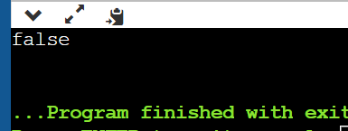
8)get length of string
import java.util.Scanner;
class Main{
public static void main(String[] args){
String greet = "Hello! World";
System.out.println("String:"+greet);
int length = greet.length();
System.out.println("Length:"+length);
}
}
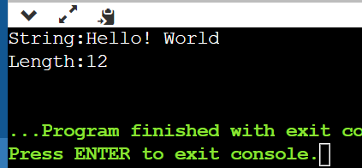
9)simple string
import java.util.Scanner;
class Main{
public static void main(String[] args){
String first = "java";
String second = "python";
String third = "javascript";
System.out.println(first);
System.out.println(second);
System.out.println(third);

}
}
